Use-Case Specification
Example 1: Hierarchical Authentication system

Sample Use-Cases Table

Use case name: Home Page ID: 1 Importance Level: High
Primary actor: All users Use Case Type: Detail, essential
Stakeholders and interests:
All users - need to open an initial page before log on.
Brief Description: This use case defines opening of the initial page.
Trigger: User opens the home page.
Type: External
Relationships:
Association: user
Include:
Extend:
Generalization:
Precondition: Must be connected to the network
Post-condition: Able to login into the system
Normal flow of events:
- User opens the homepage URL in his/her desired way.
2. The following is displayed to the user.
a. Logon: This control spawns the logon method.
b. Help: This control displays the Help page in a new window.
c. About: This control displays the About page in a new window.
d. Contact info: This control displays the contact information page in a new window.
e. Any Appropriate Hyperlinks: The controls activate the hyperlink in a new window

Alternate / exceptional flows:
1. -1a User types a wrong URL.
1 - 1b Server is down when the user tries to access the home page.

Use case name: USER LOGON ID: 2 Importance Level: High
Primary actor: All users Use Case Type: Overview, essential
Stakeholders and interests:
All users - need to log on to the application.
Brief Description:
This use case defines the process of logging on to the
System.
Trigger: User opens the logon control window.
Type : External
Relationships:
Association: user
Include: Home page
Extend:
Generalization:
Precondition: User has opened the home page
Post-condition: Able to work with the system
Normal flow of events:
1. The user opens the logon window.
2. The logon window displays username and password fields.
It also displays buttons for the
Actions: a. Sign in
b. Cancel
- The user types his/her username and password into the
fields. The password filed is hidden i.e. it displays
‘*’ in place of each character typed into the field.
4. User clicks the sign in button. (Request is submitted.)
If authentication by the host server is successful,
the user is allowed to access the system based on
the user role.

Alternate / exceptional flows :
3a - 1. The wrong username and/or password are typed.
- Logon failure redisplays the logon page with
all of the fields blanked and with an error
message showing logon failure.
3. User gets total of three chances to logon correctly.
3b - 1. The user cancels the logon window.
2. Home page will be displayed.

Figure 1: Use Case Diagram
Home
Page
Logon
Administr-ator Page
Manager
Page
User
Page
Guest
Page
Hierarchical Authentication System
Emp1
Data
Emp2
Data
Emp3
Data
<<Include>>
<<Include>>
*
*
*
*
*
Authentication File Data
All Application
Users
*

Example : let us develop an order processing software for a mail order company. They are the reseller of products purchased from various suppliers. Twice a year the company publishes a catalog of products, which is mailed to customers and other interested people. Customers purchase products by submitting a list of products with payment to the company and they fill the order and ships the products to the customer’s address. Another role of the order processing software is to track the order from the time it is received until product is shipped. They wish to ship a customer’s order by the fastest, most efficient means possible. Customers also have the facility to return items for restocking, by sometimes paying a fee.

Use case diagram
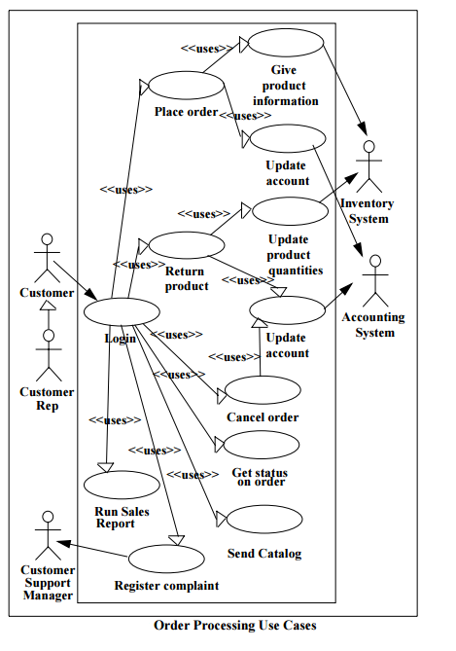

Use case description
Use case name: USER LOGIN ID: 2 Importance Level: High
Primary actor: Customer, Customer rep
Stakeholders and interests:
All users - need to log on to the application.
Brief Description:
This use case defines the process of logging on to the
System.
Trigger: User opens the logon control window.
Type : External
Relationships:
Association: user
Include: Home page
Extend:
Generalization:
Precondition: User has opened the home page
Post-condition: Able to work with the system
Normal flow of events:
1. The Use Case starts when the user starts the application.
2. The system will display the login screen
3. The user enters a username and password.
4. The system will verify the information.
5. The system will set access permissions.
6. The system will display the main screen.
7. The user will select a function
8. While the user does not select Exit loop
9. If the user selects Place Order then
8.1 Use Place Order
10.else If the user selects Return Product then
9.1 Use Return Product
11.else if the user selects Cancel Order then
10.1 Use Cancel Order
12.else if the user selects Review Order then
11.1 Use Get Status on Order
13.else if the user selects Send Catalog then
12.1 Use Send Catalog
14.else if the user selects Contact Customer Service then
13.1 Use Register Complaint
15.else if the user selects Run Sales Report and user is a Customer Rep then
14.1 Use Run Sales Report
end if
16.The user will select a function
end loop
17.The Use Case ends

Example 3: Credit card processing system
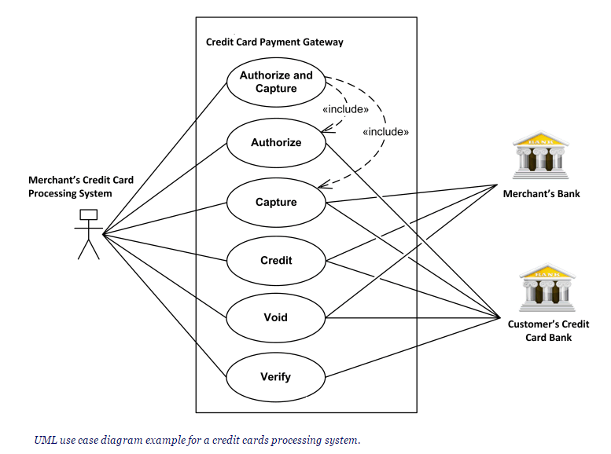

Example 4: ATM use case
